How to Access and Complete Your Intuto Training

Step 1: Open the Training Link
Click on the provided link to access the Intuto training platform.
https://bscnz.my.intuto.com/token/use?t=c3J5rEUMmt

Step 2: Log In or Register
If you have an account, log in. If not, register by following the prompts.
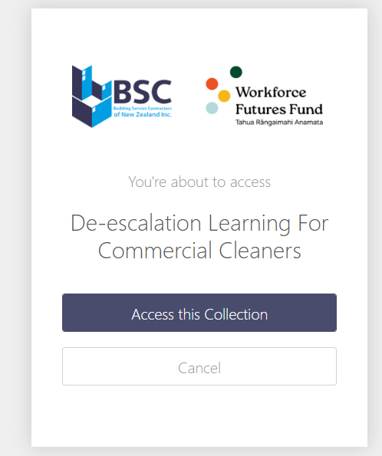

Enter email address

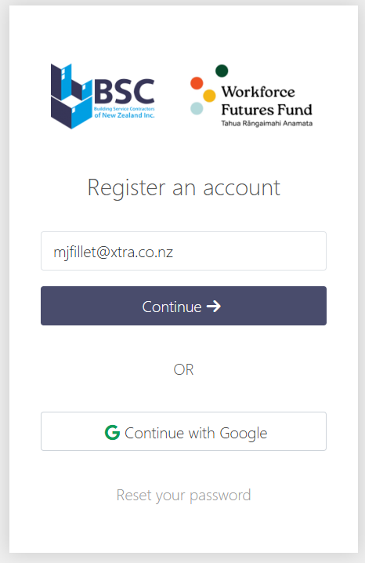

Choose your company name

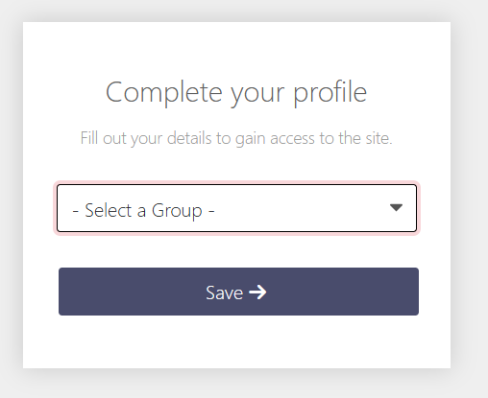

Step 3: Start the Course
Once logged in, click 'View' then click Start course.
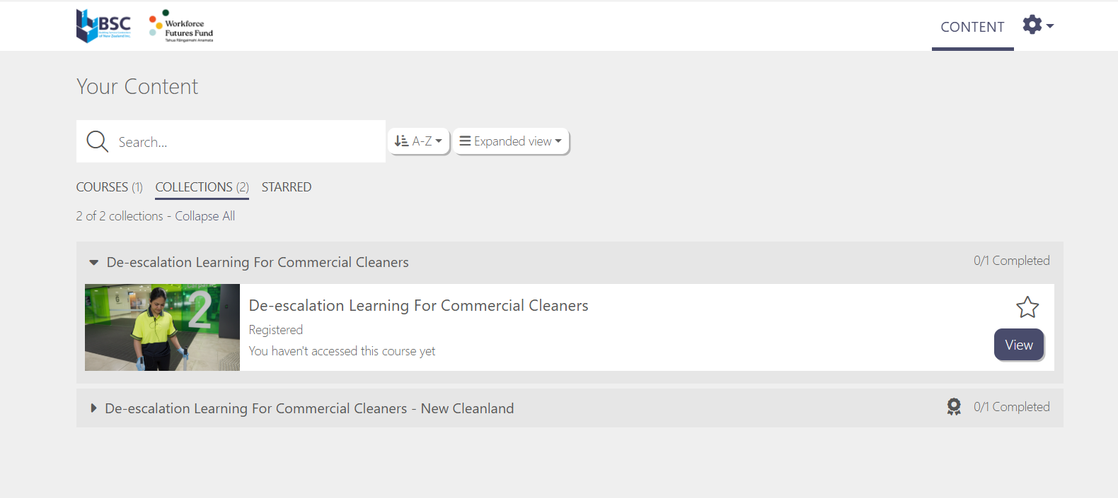

Step 4: Follow the Modules
Watch each video and complete quizzes.

Step 5: Submit and Finish
Click 'Finish Course' when all modules are complete. Download your certificate.

Step 6: Log Out
Log out after completing the course for security.

